
DIVINE AYODHYA & VARANASI EXPERIENCE
CIRCUIT: DELHI – AYODHYA – VARANASI – DELHI
In this journey, we will explore Ayodhya and Varanasi, two of the most sacred and beautiful destinations in India, situated on the banks of the holy Saryu and Ganges rivers. Renowned as major pilgrimage centres, these ancient cities hold immense spiritual, cultural, and historical significance.
Ayodhya, the birthplace of Lord Rama, is home to the magnificent Ram Mandir and several revered temples that attract devotees from across the world. Varanasi, one of the oldest living cities on earth, is famous for its sacred ghats, ancient temples, and the enchanting Ganga Aarti ceremony that takes place every evening along the banks of the River Ganga.
This journey offers a unique opportunity to experience India's rich spiritual heritage, witness timeless traditions, and immerse yourself in the divine atmosphere of two of the country's most revered pilgrimage destinations.
PUBLISHED ITINERARY:
(Subject to changes depending on circumstances)
DAY 01: 06 JUNE | DELHI TO AYODHYA
Assistance at Ayodhya airport.
Ayodhya is an ancient, sacred city in Uttar Pradesh, India, revered as the birthplace of Lord Rama, the central figure of the Ramayana, and a major Hindu pilgrimage site situated on the Saryu River. Formerly the capital of the ancient Kosala Kingdom and Oudh State, it's now a rapidly developing tourist hub, famous for the newly built Ram Mandir at the Rama Janmabhoomi site, attracting millions of devotees and visitors.
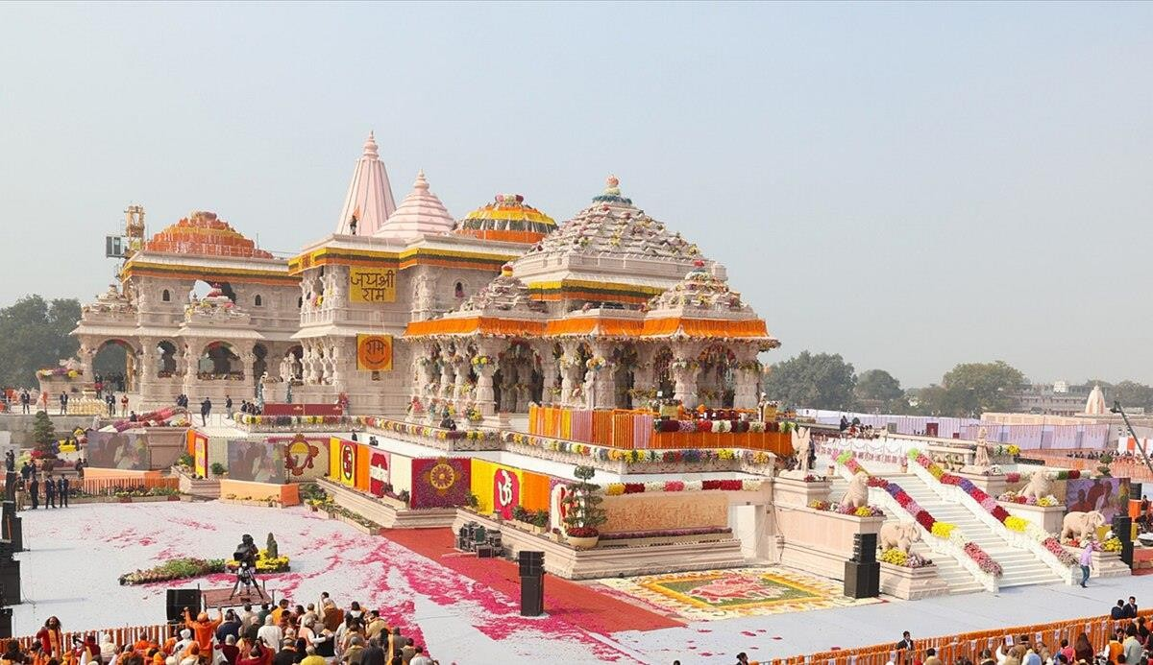
Upon arrival, transfer to the hotel. In the evening, we will go for sightseeing Ram Mandir, Shri Hanuman Garhi Mandir, Kanak Bhawan, Dashrath Marg and Saryu River etc.
Return to the hotel for overnight stay.
DAY 02: 07 JUNE | AYODHYA TO VARANASI (219 KMS / 4H 15M)
After breakfast from the hotel, we will drive to Varanasi.
Varanasi, also known as Kashi or Banaras, is one of the oldest continuously inhabited cities in the world and holds immense spiritual, cultural, and historical significance. Located on the banks of the sacred River Ganga in Uttar Pradesh, India, Varanasi is regarded as the spiritual capital of India.
The city is famous for its ghats, where pilgrims perform rituals, take holy dips, and conduct evening Ganga Aarti, a mesmerizing spiritual ceremony. Varanasi is a major centre of Hinduism, Buddhism, and Jainism, with nearby Sarnath being the place where Lord Buddha delivered his first sermon.
Upon arrival check in & later, we will go to the banks of the Ganges River to witness the evening Aarti ceremony. After the ceremony, return to the hotel and overnight stay.

DAY 03: 08 JUNE | IN VARANASI | SARNATH VISIT
At dawn, we will take a boat ride on the Ganges, where we will observe devotees along the ghats, purifying themselves and making their offerings. After that return to the hotel for breakfast.
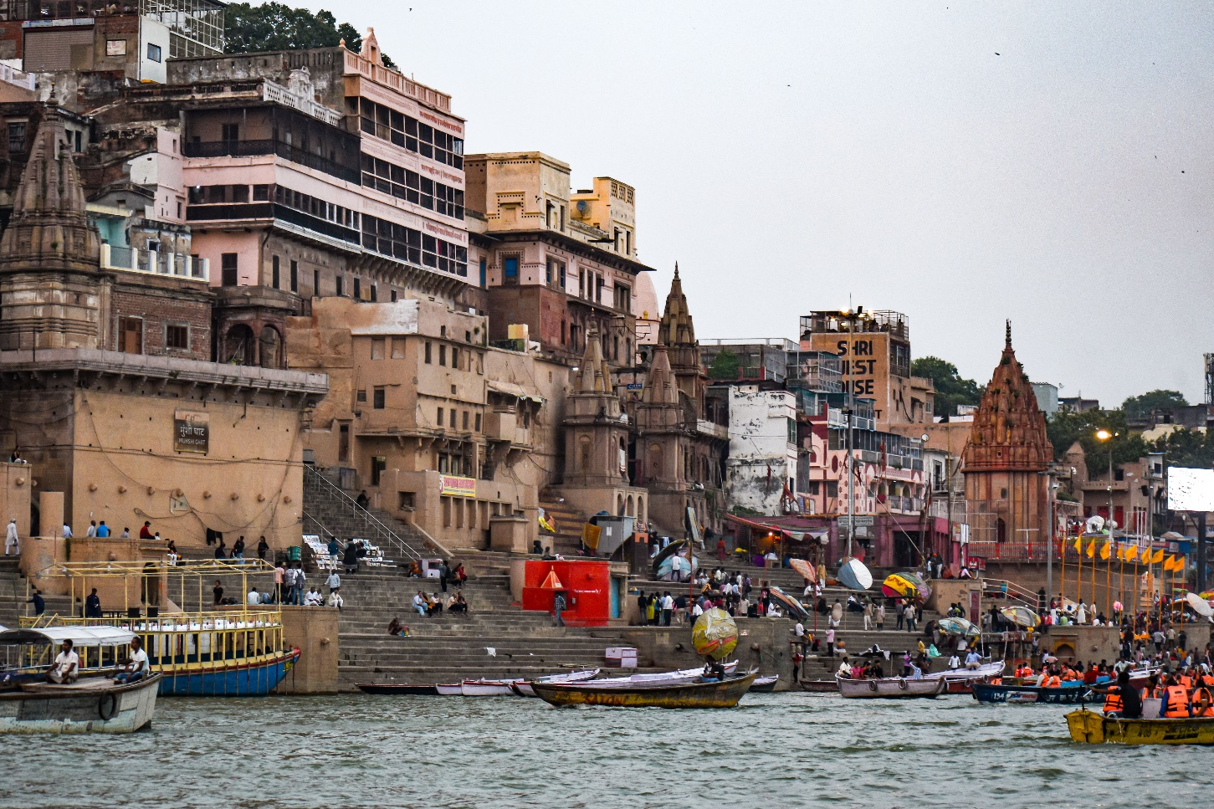
At the scheduled time, we will continue with a visit to Sarnath, where Buddha delivered his first sermon. We will visit the museum, the remaining stupas, and the garden with a statue of Buddha.
Sarnath, near Varanasi, is a profoundly sacred Buddhist pilgrimage site where Gautama Buddha first taught the Dharma, establishing Buddhism after his enlightenment; it features ancient ruins, stupas (like Dhamek Stupa), monasteries, the iconic Ashoka Pillar with the Lion Capital, and the Sarnath Museum, making it a key center for Buddhist art, history, and culture, easily reachable from Varanasi by road or train.
After the visit, return to the hotel. Overnight stay.
DAY 04: 09 JUNE | DEPARTURE FROM VARANASI
After breakfast, free time until the transfer to the airport. Boarding of the return flight to Delhi. Arrival and end of services, taking home unforgettable memories of the sacred cities of Ayodhya and Varanasi, renowned for their spiritual heritage, ancient traditions, and riverside beauty, as well as India's rich culture, history, and architecture.
“THANK YOU FOR CHOOSING TO EXPLORE WITH US!”

